Division of reproductive health

DP report

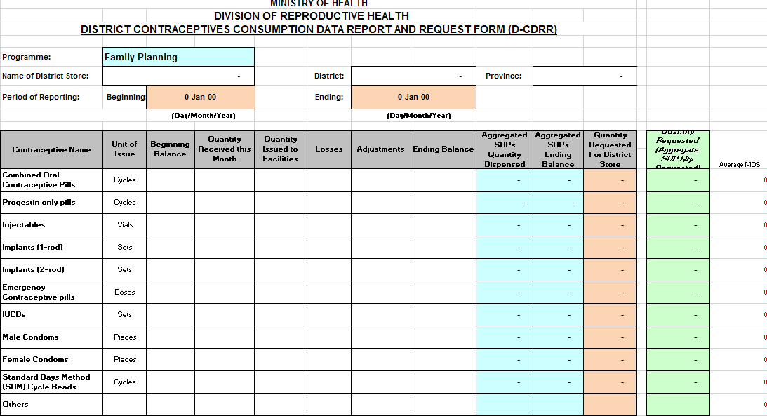

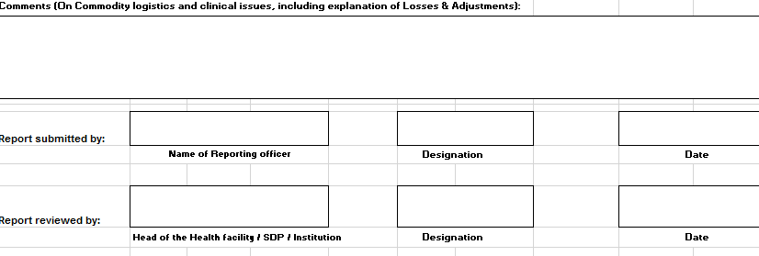

Facility report

|  |  |  |  |  |  |  |  |  |  |  |  |  |  |  |
| --- | --- | --- | --- | --- | --- | --- | --- | --- | --- | --- | --- | --- | --- | --- |
| **Contraceptive** | **Beginning Balance** | **Received This Month** | **Dispensed** | **Losses** | **Adjustments** | | | | **Ending Balance** | | | **Quantity Requested** | | |
| **Positive** | **Negative** | | |
| Combined Oral contraceptive Pills |  |  |  |  |  |  | | |  | | |  | | |
| Progestin only pills |  |  |  |  |  |  | | |  | | |  | | |
| Injectables |  |  |  |  |  |  | | |  | | |  | | |
| Implants (1-Rod) |  |  |  |  |  |  | | |  | | |  | | |
| Implants (2-Rod) |  |  |  |  |  |  | | |  | | |  | | |
| Emergency Contraceptive pills |  |  |  |  |  |  | | |  | | |  | | |
| IUCDs |  |  |  |  |  |  | | |  | | |  | | |
| Male Condoms |  |  |  |  |  |  | | |  | | |  | | |
| Female Condoms |  |  |  |  |  |  | | |  | | |  | | |
| Cycle Beads |  |  |  |  |  |  | | |  | | |  | | |
| Others |  |  |  |  |  |  | | |  | | |  | | |
| **SERVICE STATISTICS** (Indicate only the number of ***Clients issued with Contraceptives*** | | | | | New Clients | |  | | | Natural FP Counseling | | |  | |
|  | New Clients | Revisits | Change of method | | Revisits | |  | | | Natural FP Referrals | | |  | |
| from | to |
| Combined oral contraceptive Pills |  |  |  |  |  | | | | | | | | | |
| Progestin only pills |  |  |  |  | **HIV COUNSELING AND TESTING** | | | | | | | | | |
| Injectables |  |  |  |  | Counseled and Tested | | | Referred for Counseling and Testing | | | Known HIV Status | | | |
| Implants (1-Rod) |  |  |  |  | 1 | | | 2 |
| Implants (2-Rod) |  |  |  |  |  | | |  | | |  | | |  |
| IUCDs |  |  |  |  |  | | | Sterilization | | | | | | |
| Male Condoms |  |  |  |  | Males | | |  | | | |
| Female Condoms |  |  |  |  | Females | | |  | | | |
| Cycle Beads |  |  |  |  | Referrals | | |  | | | |
| Others |  |  |  |  | Cases for Emergency Pills | | | | | |  | | | |